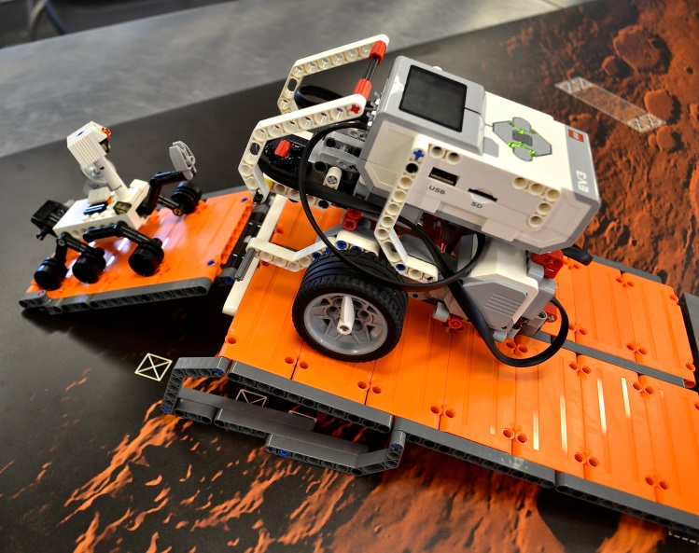

**Teamwork skills:**

* Communicate effectively
* Work collaboratively
* Make decisions
* Negotiate and resolve conflict
* Develop leadership skills

ROBOTICS CLUB

**This is to certify that**

**has successfully completed the Robotics Club program, and has developed these skills:**

**Robotics skills (using LEGO® MINDSTORMS® EV3):**

**Building:**

* Edubot
* Driving base
* Attaching sensors
* Attachments
* Creative building

**Programming:**

* Straight move
* Curved move
* Wait for
* Add sound
* Colour sensor
* Ultrasonic sensor
* Iterations and branching

Signed: ______________