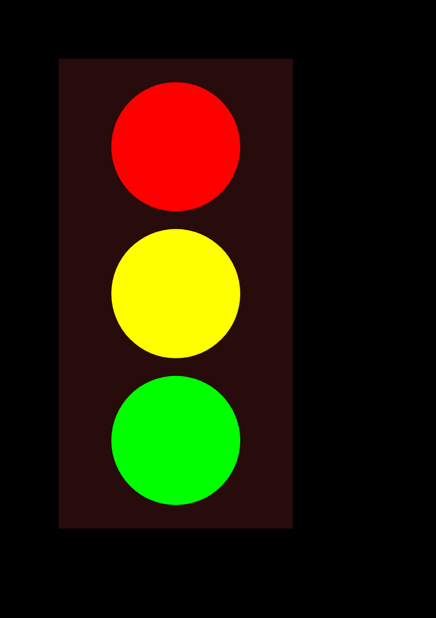

Print and use for transitioning in conjunction with

**Visual Schedules**

Use these arrows with the traffic light system and move according to progress of activity/schedule.